Part I: Interview
time:
4 minutes

Teacher:
In the first part of this test, I am going to ask each of you some questions.
In the interview, I will ask each of you each question in the following way:
A, then B / B, then A / A, then B … and so on.
We will start when you are ready.

- What can you tell me about yourself and your family?

- Is your family a big or a small one?

- What are the advantages / disadvantages of a big / small family?

- Would you describe yourself as an active or a lazy person? Why?

- What kind of holiday do you enjoy most?

- Which time of the year do you like best? Why?

This is the end of this task.
______________________________________________________________________
Part II: Monologue A

Teacher: Now I'd like each of you to talk about pictures. You have about 2 minutes each.
Candidate A: You will start. Here is your material.
time:
2 minutes

- Describe one of the pictures.
- How might the people in the picture feel and why?
- What is your dream job and why would you like to work in this field of work/ job?

Shall I repeat the instructions?
_______________________________________________________________________
Candidate B: Now it's your turn. Here is your material.
time:
2 minutes

- Describe one of the pictures.
- How might the people in the picture feel and why?
- What kind of movies do you prefer?

Shall I repeat the instructions?
______________________________________________________________________

Part III: Paired Discussion
time:
4 minutes

Teacher: Now I'd like each of you to talk to each other.

You and your friend plan to spend a day in New York City but you want to visit
different sights and places. Discuss and agree on three sights and places that
you want to visit. Give reasons for your decision.

Part II: Monologue A

- Describe one of the pictures.
- How might the people in the picture feel and why?
- What is your dream job and why would you like to work in this field of work/ job?





- Describe one of the pictures.
- How might the people in the picture feel and why?
- What kind of movies do you prefer?



Part III: Paired Discussion

You and your friend plan to spend a day in New York City but you want to visit different sights and places. Discuss and agree on three sights and places that you want to visit. Give reasons for your decision.
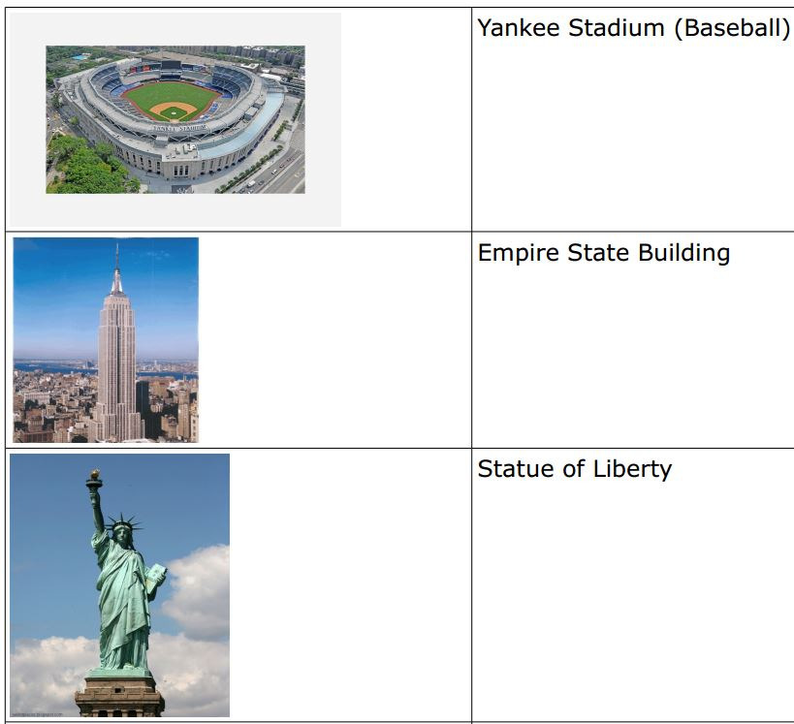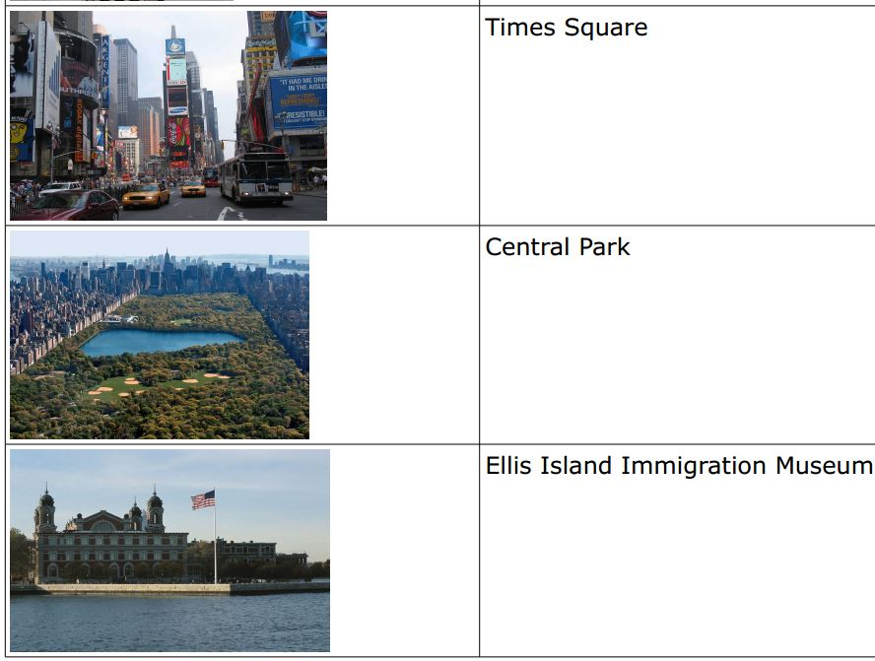

time:
4 minutes

